Graphs and plots HW

Hamed

1/31/2020

#### 1. Use the diamonds dataset that comes with R

library(ggplot2)  
data("diamonds")  
attach(diamonds)  
head(diamonds)

## # A tibble: 6 x 10  
## carat cut color clarity depth table price x y z  
## <dbl> <ord> <ord> <ord> <dbl> <dbl> <int> <dbl> <dbl> <dbl>  
## 1 0.23 Ideal E SI2 61.5 55 326 3.95 3.98 2.43  
## 2 0.21 Premium E SI1 59.8 61 326 3.89 3.84 2.31  
## 3 0.23 Good E VS1 56.9 65 327 4.05 4.07 2.31  
## 4 0.290 Premium I VS2 62.4 58 334 4.2 4.23 2.63  
## 5 0.31 Good J SI2 63.3 58 335 4.34 4.35 2.75  
## 6 0.24 Very Good J VVS2 62.8 57 336 3.94 3.96 2.48

#### 2. Count the number of rows by clarity

table(diamonds$clarity)

##   
## I1 SI2 SI1 VS2 VS1 VVS2 VVS1 IF   
## 741 9194 13065 12258 8171 5066 3655 1790

#### 3. What are the unique values for cut?

unique(cut)

## [1] Ideal Premium Good Very Good Fair   
## Levels: Fair < Good < Very Good < Premium < Ideal

#### 4. Tabulate the frequency (no of diamonds) by cut

table(diamonds$cut)

##   
## Fair Good Very Good Premium Ideal   
## 1610 4906 12082 13791 21551

#### 5. Find the mean carat size by color

library(dplyr)

##   
## Attaching package: 'dplyr'

## The following objects are masked from 'package:stats':  
##   
## filter, lag

## The following objects are masked from 'package:base':  
##   
## intersect, setdiff, setequal, union

diamonds %>%  
 group_by(color) %>%  
 summarise_at(vars(carat), funs(mean(., na.rm=TRUE)))

## Warning: funs() is soft deprecated as of dplyr 0.8.0  
## Please use a list of either functions or lambdas:   
##   
## # Simple named list:   
## list(mean = mean, median = median)  
##   
## # Auto named with `tibble::lst()`:   
## tibble::lst(mean, median)  
##   
## # Using lambdas  
## list(~ mean(., trim = .2), ~ median(., na.rm = TRUE))  
## This warning is displayed once per session.

## # A tibble: 7 x 2  
## color carat  
## <ord> <dbl>  
## 1 D 0.658  
## 2 E 0.658  
## 3 F 0.737  
## 4 G 0.771  
## 5 H 0.912  
## 6 I 1.03   
## 7 J 1.16

#### 6. Use a bar chart to find which cut has the most amount of diamonds

require(lattice)

## Loading required package: lattice

barchart(table(diamonds$cut),main="Number of diamonds per cut")

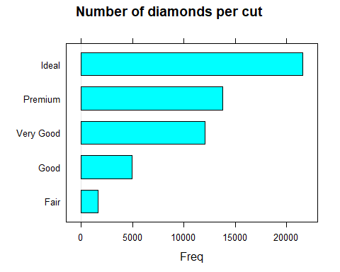

#### 7. Check the distribution of the carat size. How can you describe the distribution?

* According to the plots the data is mostly found around the mean which is 0.79 but has a lot of outliers and thus the data is rightly skewed.

# Histogram plot  
hist(diamonds$carat,main = "Histogram for carat size")

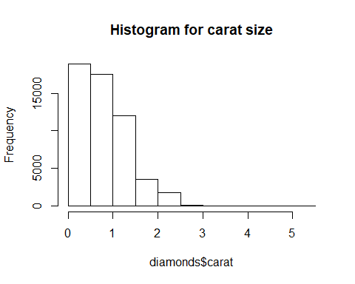

# Boxplot  
boxplot(diamonds$carat,main="Boxplot for carat size")

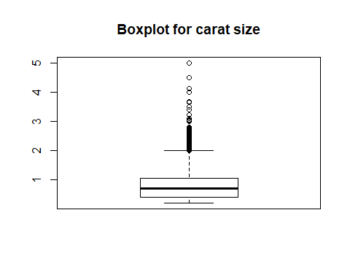

#Density plot  
d <- density(diamonds$carat)  
plot(d, type="n", main="Density plot for carat size")  
polygon(d, col="red", border="gray")

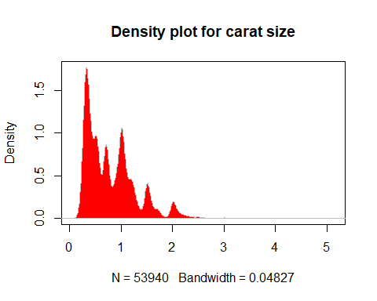

#### 8. Is there a relationship between carat size and price? Check using a graph.

* From the graph the there is a positive slope showing carat size has a positive relationship with price.

ggplot(diamonds, aes(carat,price)) + geom_point(alpha=0.3,col="#0000ff22", pch=16,cex=3)

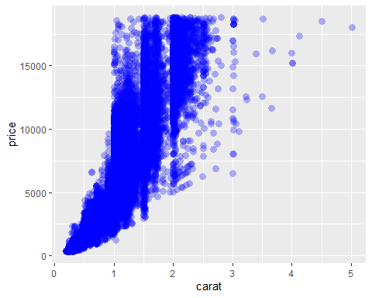

#### 9. Which color has the maximum variability in the price? Use a graph to find out.

-From the boxplots the color E shows higher variability in price.

qplot(color,price,data=diamonds, geom = "boxplot")

